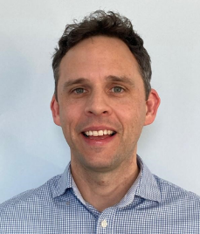 Alex Pollard
Alexander Pollard is a Consultant in Restorative Dentistry at Torbay and South Devon NHS Foundation Trust, and a Specialist in Restorative Dentistry and Periodontics. He is also a Consultant Clinical Research Fellow at the University of Bristol, and founding co-chair of the South West Oncology Restorative Network (CASP).
Alex works predominantly with patients who have experience of head and neck cancer, focussing on the restorative management and oral rehabilitation of these patients using both digital and conventional workflows. His clinical and academic interests include implant-based rehabilitation and quality of life in head and neck cancer patients, and periodontics.
Until recently he was the Chair of the Soth West Restorative Managed Clinical Network and is particularly proud of the Cancer Action Support Practice (CASP) network that is now being expanded across the South West.

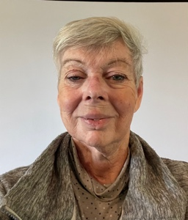 Michelle Kennedy
Michelle lives in Devon where she moved to from London 15 years ago. She worked for over 25 years in Local and National Government at senior and executive levels, latterly as an adviser on tackling Child Poverty and social inclusion. She then worked as an independent adviser to Save The Children, the Joseph Rowntree Foundation and the National Children’s Bureau.
Since 2004 Michelle has been living with recurrent oral head and neck cancer, most recently in 2025. She has had 4 neck dissections, a hemi glossectomy in 2016 and radiotherapy. She is dysphagic, and receives all liquid and food, including water, through a RIG.

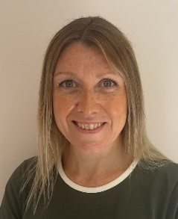 Deborah Howland
Debs is dietitian who has worked at Torbay Hospital since 2004. She has looked after people with head and neck cancer since 2005 as part of the MDT. She has contributed to national guidelines on the nutritional management of head and neck cancer, including chapters in the Manual of Dietetic Practice and ENT UK guidelines alongside being part of the British Dietetic Association Oncology Committee since 2009 working on various projects. She has special interests in muscle health and taste, and Debs is passionate about enhancing the quality of life and the joy of eating for people with head and neck cancer. There are often lifelong challenges with lack of enjoyment of food and compromised nutritional status affecting long term health after treatment has managed the cancer.

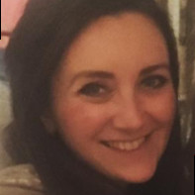 Rebecca Iles
Rebecca is a Consultant in Special Care Dentistry at the Royal Devon University Healthcare NHS Foundation Trust, providing dental care to patients with complex needs.
She graduated from Barts and The London School of Medicine and Dentistry in 2014, following completion of a Biochemistry degree at the University of Warwick. After graduating she worked in Oral and Maxillofacial Surgery, restorative and community dentistry. Alongside her Specialist training, which she completed in 2021, she undertook an MSc in Special Care Dentistry at Kings College London. It was during her MSc that she developed an interest in the area of palliative care, and she carried out her research project and thesis on the experiences of oral health in end of life care.
Rebecca is on the executive committee for the British Society of Special Care Dentistry, the RCSEd Special Care Dentistry Advisory Board and Chair of The regional Sedation Network Meeting. She has a strong interest in education, having completed a post graduate certificate in Medical Education. Rebecca examines for the RCSEd Diplomas in Special Care Dentistry & Sedation. She is an Educational Supervisor for Special Care Dentistry and teaches undergraduates at the Peninsula School of Dentistry.

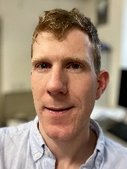 John Murphy
John is currently a Specialty Registrar in Oral and Maxillofacial Surgery in Exeter. He qualified from Bristol in 2014 with the gold medal and oral surgery prize and after a year in practice and SHO jobs in OMFS up north moved to New Zealand for a year to spend a bit more time outside. He then completed medicine at Leeds in 2021 and moved back to sunny Devon to complete a further 3 years doing various medical and surgical jobs before starting higher training in OMFS in 2024 on the Peninsula rotation.
He has a strong interest in the surgical management of head and neck cancer and facial trauma and has published in peer review journals as well as presenting nationally and internationally. John holds an MSc as well as MJDF and MRCS. He has an interest in leadership and management having previously worked in this area as part of his academic foundation programme along with a completing a Postgraduate Certificate in Healthcare Management and Leadership. Outside of work, he enjoys spending time outside cycling or running depending on whether his 3 small children allow it.

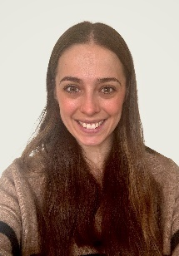 Sophie Bryant
Sophie is a Specialist in Special Care Dentistry working within Aneurin Bevan University Health Board, with a particular interest in improving access to oral healthcare for patients with complex needs. Sophie has been a member of the SIG committee for the past 3.5 years, and during this time has had the pleasure to contribute to the updated Dysphagia Guidelines.

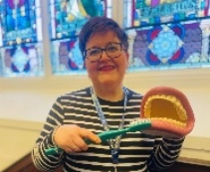 Carolyn Joyce
Carolyn Joyce is a Lead for Mouthcare Improvement within the Community Dental Team at Aneurin Bevan University Health Board (ABUHB). With nearly 40 years of NHS experience, she specializes in oral health for vulnerable adults and has been recognized for her work in effective oral hygiene training and education, often featuring in the health board's health improvement videos and public Facebook page. Carolyn serves as the South Wales Dental Care Professional (DCP) representative on the All-Wales Special Interest Group for Special Oral Health Care (SIG) and the British Society of Gerodontology.
Sophie and Carolyn will be discussing the practical implications of the new dysphagia guidelines for the whole dental team.

